

**AAUP Library System**

**Web Programming l**

**Prepared By:**

|  |  |
| --- | --- |
| **Sajeda Dnoof** | **21511055** |
| **Wesam Amarneh** | **21510557** |
|  |  |

**Instructor**

**Dr. Mujahed Eleyat**

Table of Contents

List of Figures 3

Introduction 4

Explanation the system 5

# List of Figures

Figure 1-1 Entity Relationship Diagram 5

Figure 1-2 Data of table Books 6

Figure 1-3 Data of table Users 6

Figure 1-4 Data of table Owners 7

Figure 1-5 Some views that used 7

# Introduction

We created this web site for our library university, in our system we want to get the books details from the library and put them in the website, that will let the users regardless that the user from the university or not, he can register in the site and there is another feature that let user to change his password if he forgets it.

When user login to the website he can search of book by it’s name, and he can see every section for alone and see the books inside it, then he can reserve any book he want but the book must be available in the library, when he pressed on button to reserved the website tell him to choose the deadline that he want to retrieve the book, the site let him to put a last deadline after month of reserved.

And don’t forget that there is an owner in the library and website, this owner can see all reservation for now and remove any reserve after the user retrieve the book, in addition to add, update and remove books to/from the library.

Finally, we will talk about that the user can request an delay to retrieve the book, this delay is provided by the website for five days, but the owner must accept this request to extend the deadline.

The figure below shows the entity relationship for the system.

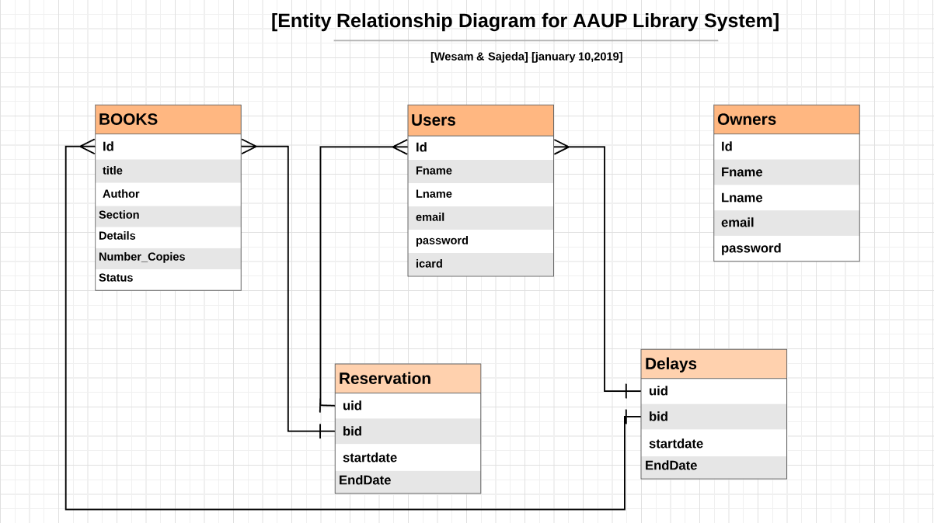

*Figure 1-1 Entity Relationship Diagram*

We have many tables in our system, first one is table of books which has 15 books that was split to three section:

* Arts
* Science
* Math

And see the status of every book that is available or not, more details shown in figure below.

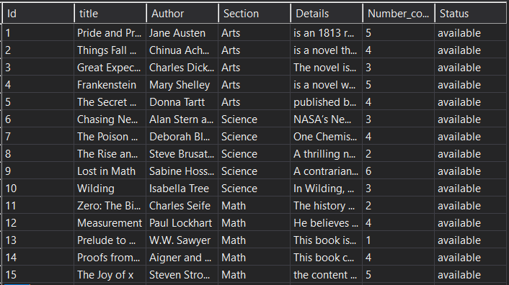

*Figure 1-2 Data of table Books*

As shown in figure below the contents of table users, we have for now six users that was registered in the web site.

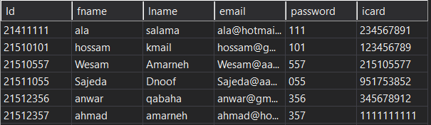

*Figure 1-3 Data of table Users*

And finally, here the contents of table owners, we have three owners for now as shown in figure below.

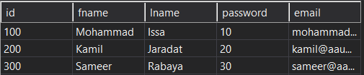

*Figure 1-4 Data of table Owners*

And make two views to use it the owner to:

* Display all Reservations.
* Display the delays details to accept or reject it.

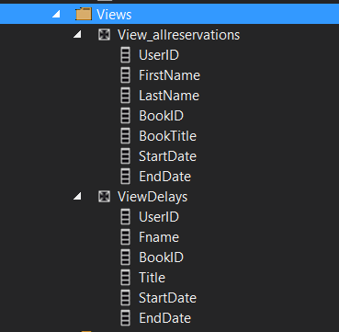

*Figure 1-5 Some views that used*